Program Schedule
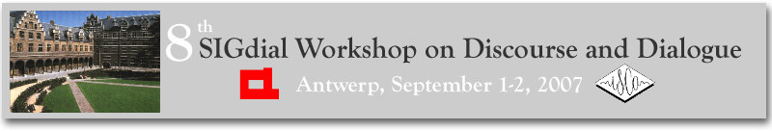

Saturday, September 1, 2007
8:00 – 9:00 am | Conference Registration
9:00 – 9:15 am | Opening Remarks
9:15 – 10:15 am | Keynote Address  Rationality and Conversation  Prof. Herbert H. Clark, Stanford University
10:15 – 10:40 am | Coffee Break
10:40 – 12:20 am | Session: Multi-Party Dialogue  Area Chair: David Traum  10:40 – 11:05 am: Collective States of Understanding , Arash Eshghi and Patrick G.T. Healey  11:05 – 11:30 am: Contrasting the Automatic Identification of Two Discourse Markers in Multiparty Dialogues, Andrei Popescu-Belis and Sandrine Zufferey  11:30 – 11:55 am: Detecting and Summarizing Action Items in Multi-Party Dialogue, Matthew Purver, John Dowding, John Niekrasz, Patrick Ehlen, Sharareh Noorbaloochi and Stanley Peters  11:55 – 12:20 Detecting Arguing and Sentiment in Meetings, Swapna Somasundaran, Josef Ruppenhofer and Janyce Wiebe
12:20 – 1:30 pm | Poster Session  Walking Lunches
1:30 – 2:45 pm | Session: Spoken and Multimodal Dialogue Systems  Area Chair: Marilyn Walker  1:30 – 1:55 pm: CHAT To Your Destination, Fuliang Weng, Baoshi Yan, Zhe Feng, Florin Ratiu, Madhuri Raya, Brian Lathrop, Annie Lien, Rohit Mishra, Sebastian Varges, Feng Lin, Matthew Purver, Yao Meng, Harry Bratt, Tobias Scheideck and Zhaoxia Zhang  1:55 – 2:20 pm: Commute UX: Telephone Dialog System for Location-based Services, Ivan Tashev, Michael Seltzer, Yun-Cheng Ju, Dong Yu and Alex Acero  2:20 – 2:45 pm: Corpus-Based Training of Action-Specific Language Models,  Lars Schillingmann, Sven Wachsmuth and Britta Wrede
2:45 – 3:10 pm | Tea Break
3:10 – 4:00 pm | Session: Spoken and Multimodal Dialogue Systems (Continued)  3:10 – 3:35 pm: Negotiating Spatial Goals with a Wheelchair, Thora Tenbrink and Hui Shi  3:35 – 4:00 pm: Releasing a Multimodal Dialogue System into the Wild: User Support Mechanisms, Alexander Gruenstein and Stephanie Seneff
4:00 – 5:00 pm | Short Paper Session: Spoken and Multimodal Dialogue Systems  4:00 – 4:15 pm: Analysis of User Reactions to Turn-Taking Failures in Spoken Dialogue Systems, Mikio Nakano, Yuka Nagano, Kotaro Funakoshi, Toshihiko Ito, Kenji Araki, Yuji Hasegawa and Hiroshi Tsujino  4:15 – 4:30 pm: Comparing Spoken Dialog Corpora Collected with Recruited Subjects versus Real Users, Hua Ai, Antoine Raux, Dan Bohus, Maxine Eskenazi and Diane Litman  4:30 – 4:45 pm: Dealing with DEAL: A dialogue system for conversational training, Anna Hjalmarsson, Preben Wik and Jenny Brusk  4:45 – 5:00 pm: Referring under Restricted Interactivity Conditions, Raquel Fernandez, Tatjana Lucht and David Schlangen
5:00 – 6:00 pm | SIGDIAL Business Meeting
6:00 – 8:00 pm | Reception (Sponsored by John Benjamins Publishing Company)

Sunday, September 2, 2007
9:00 – 10:15 am | Session: Conversation Modeling  Area Chair: Jan Alexandersson  9:00 – 9:25 am: A Multidimensional Approach to Utterance Segmentation and Dialogue Act Classification , Jeroen Geertzen, Volha Petukhova and Harry Bunt  9:25 – 9:50 am: Accented Pronouns and Unusual Antecedents: A Corpus Study, Anubha Kothari  9:50 – 10:15 am: Evaluating Combinations of Dialogue Acts for Generation, Simon Keizer and Harry Bunt
10:15 – 10:40 am | Coffee Break
10:40 – 11:30 am | Session: Conversation Modeling (Continued)  10:40 – 11:05 am: Measuring Adaptation Between Dialogs, Svetlana Stenchikova and Amanda Stent  11:05 – 11:30 am: Token-based Chunking of Turn-internal Dialogue Act Sequences, Piroska Lendvai and Jeroen Geertzen
11:30 – 12:15 pm | Short Paper Session: Conversation Modeling  11:30 – 11:45 am: A Comprehensive Disfluency Model for Multi-Party Interaction, Jana Besser and Jan Alexandersson  11:45 – 12:00 pm: Experimental modeling of human-human multi-threaded dialogues in the presence of a manual-visual task, Alexander Shyrokov, Andrew Kun and Peter Heeman  12:00– 12:15 pm: Modeling Vocal Interaction for Text-Independent Classification of Conversation Type, Kornel Laskowski, Mari Ostendorf and Tanja Schultz
12:15 – 1:25 pm | Poster Session  Walking Lunches
1:25 – 2:40 pm | Session: Dialogue Management  Area Chair: Oliver Lemon  1:25 – 1:50 pm: Dialogue management for automatic troubleshooting and other problem-solving applications, Johan Boye  1:50 – 2:15 pm: Implicitly-supervised learning in spoken language interfaces: an application to the confidence annotation problem, Dan Bohus and Alexander Rudnicky  2:15 – 2:40 pm: Planning Dialog Actions, Mark Steedman and Ronald Petrick
2:40 – 3:05 pm | Tea break
3:05 – 3:30 pm | Session: Dialogue Management (Continued)  3:05 – 3:30 pm: Statistical User Simulation with a Hidden Agenda, Jost Schatzmann, Blaise Thomson and Steve Young
3:30 – 4:00 pm | Short Paper Session: Dialogue Management  3:30 – 3:45 pm: An Empirically Based Computational Model of Grounding in Dialogue, Harry Bunt, Roser Morante and Simon Keizer  3:45 – 4:00 pm: Pragmatic Usage of Linear Regression Models for the Predicting of User Judgments, Klaus-Peter Engelbrecht and Sebastian Möller
4:00 – 4:15 pm | Closing Remarks

Poster Session (Saturday, September 1)

A Model of Compliance and Emotion for Potentially Adversarial Dialogue Agents
Antonio Roque and David Traum

Acquiring and Evaluating a Dialog Corpus through a Dialog Simulation Technique
David Griol, Lluis F. Hurtado, Emilio Sanchis and Encarna Segarra

An Empirical View on IQA Follow-up Questions
Manuel Kirschner and Raffaella Bernardi

An Implemented Method for Distributed Collection and Assessment of Speech Data
Alexander Siebert, David Schlangen and Raquel Fernández

Beyond Repair? Testing the Limits of the Conversational Repair System
David Schlangen and Raquel Fernández

Dialogue Policy Learning for combinations of Noise and User Simulation: transfer results
Oliver Lemon and Xingkun Liu

Dynamic n-best Selection and Its Application in Dialog Act Detection
Junling Hu, Fabrizio Morbini, Fuliang Weng and Xue Liu

Emergent Conversational Recommendations: A Dialogue Behavior Approach
Pontus Wärnestål, Lars Degerstedt and Arne Jönsson

Exploiting Semantic and Pragmatic Information for the Automatic Resolution of Spatial Linguistic Expressions
Andrea Corradini

Hassan: A Virtual Human for Tactical Questioning
David Traum, Antonio Roque, Anton Leuski, Panayiotis Georgiou, Jillian Gerten, Bilyana Martinovski, Shrikanth Narayanan, Susan Robinson and Ashish Vaswani

Identifying formal and functional zones in film reviews
Heike Bieler, Stefanie Dipper and Manfred Stede

Poster Session (Sunday, September 2)

Introducing Utterance Verification in Spoken Dialogue System to Improve Dynamic Help Generation for Novice Users
Kazunori Komatani, Yuichiro Fukubayashi, Tetsuya Ogata and Hiroshi G. Okuno

Making grounding decisions: Data-driven estimation of dialogue costs and confidence thresholds
Gabriel Skantze

On the training data requirements for an automatic dialogue annotation technique
Carlos D. Martínez-Hinarejos

Practical dialogue manager development using POMDPs
Trung H. Bui, Boris van Schooten and Dennis Hofs

Problem-Sensitive Response Generation in Human-Robot Dialogs
Petra Gieselmann and Mari Ostendorf

Rapid Development of Dialogue Systems by Grammar Compilation
Björn Bringert

Resolving "You" in Multi-Party Dialog
Surabhi Gupta, John Niekrasz, Matthew Purver and Dan Jurafsky

SIDGRID: A Framework for Distributed, Integrated Multimodal Annotation, Archiving, and Analysis
Gina-Anne Levow

ScIML: Model-based Engineering of Voice User Interfaces
Jörn Kreutel

Tutoring in a Spoken Language Dialogue System
Jaakko Hakulinen, Markku Turunen and Kari-Jouko Räihä

Using Speech Acts in Logic-Based Rhetorical Structuring for Natural Language Generation in Human-Computer Dialogue
Vladimir Popescu, Jean Caelen and Corneliu Burileanu

Invited Keynote Speaker

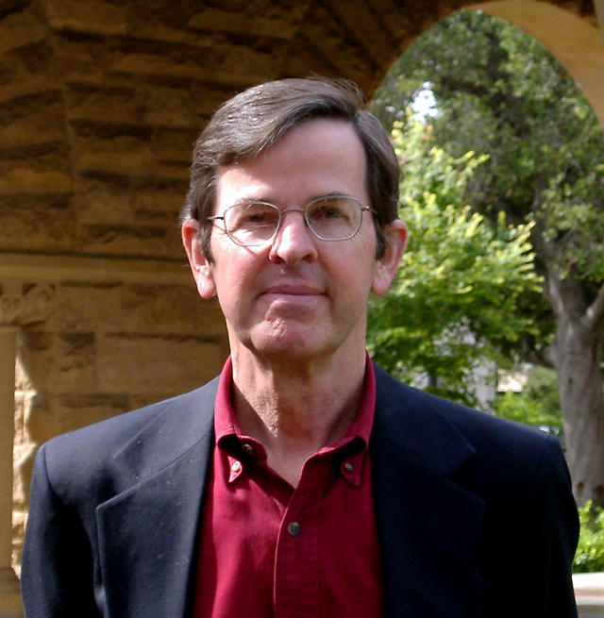

“Rationality and Conversation”

Herbert H. Clark
Professor of Psychology
Stanford University

In the model of language use proposed by philosopher H. Paul Grice, people in conversation recognize “a common purpose or set of purposes, or at least a mutually accepted direction,” and they cooperate in contributing to those purposes. Grice went on to argue, “Talking [is] a special case or variety of purposive, indeed rational, behavior.” But Grice tacitly assumed a type of omniscient rationality: People in conversation have perfect knowledge of the language and the current common ground, and they have an unlimited processing capacity in choosing what to say. In reality, people’s rationality is bounded, and that leads to quite a different view of language use. I take up some of the consequences of bounded rationality in language use.

BIOGRAPHY: Herbert H. Clark is Professor of Psychology at Stanford University. He is the author of several books on language and language use, including Psychology and Language (a textbook co-authored with Eve V. Clark), Arenas of Language Use, and Using Language. He is also author of over one hundred research articles and chapters. His research is concerned with speaking and understanding in interactive communication, especially conversation. Clark was a John Simon Guggenheim Fellow and a fellow at the Center for Advanced Study in the Behavioral Sciences. He was elected to the American Academy of Arts and Sciences and to the Royal Dutch Academy of Arts and Sciences.

